**WINDOWS** ScreenChangePing.py

These are the package dependencies for this script:

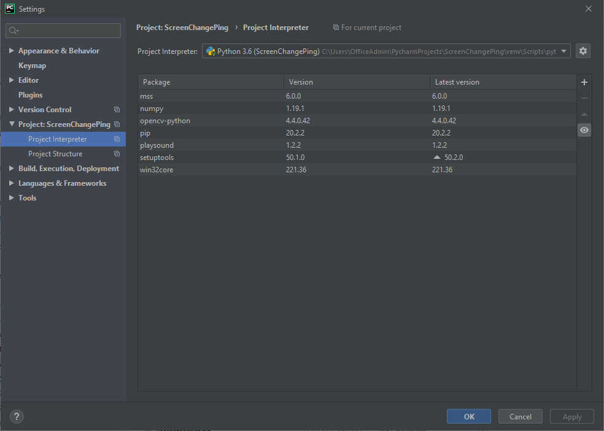

You will need to pip install: mss; numpy; opencv-python; and playsound for this to work properly.

Initial setup – define your capture rectangle. Once defined, that is where the GTT Chat window should remain. Start the program, then locate the folder where the code resides to view the ScreenshotB.png file. That shows you the area of the screen that is actually being captured. Adjust the TOP/LEFT/WIDTH/HEIGHT to adjust to the correct location and size. This should be the same location and dimensions of the GTT Chat window.

You can change the following variables in the code:

DISPLAY = 2  
TOP = 500  
LEFT = 500  
WIDTH = 200  
HEIGHT = 500  
PING_SOUND = "C:\\WINDOWS\\media\\Windows Balloon.wav"  
CHECK_FREQUENCY = 5 # value in seconds  
MUTE_AFTER_PING = 60 # value in seconds

DISPLAY = which monitor (assuming more than one) does the chat window live on?

TOP/LEFT = the top left corner coordinates (pixels) of the capture rectangle

WIDTH/HEIGHT = the width and height of the capture rectangle

PING SOUND = the path to the WAV file that should sound when a change in the screenshot is detected.

CHECK_FREQUENCY = number of seconds between screenshots

MUTE_AFTER_PING = number of seconds to wait before resuming change detection

GENERAL USAGE:

* Keep the GTT chat window in the same place every time, and you won’t have to adjust the Python code.
* Run the Python code from the command line, minimize it and leave it running. Ctrl C to stop it.